Blender Basics
- Commonly, you are going to be using weird keybinds. While there is good documentation on what these keybinds are, I still highly recommend learning the functions, then searching for them over trying to memorize keybinds.
- To those of you who have used Maya, you will notice blenders layout to be very different. I will point out those differences here:
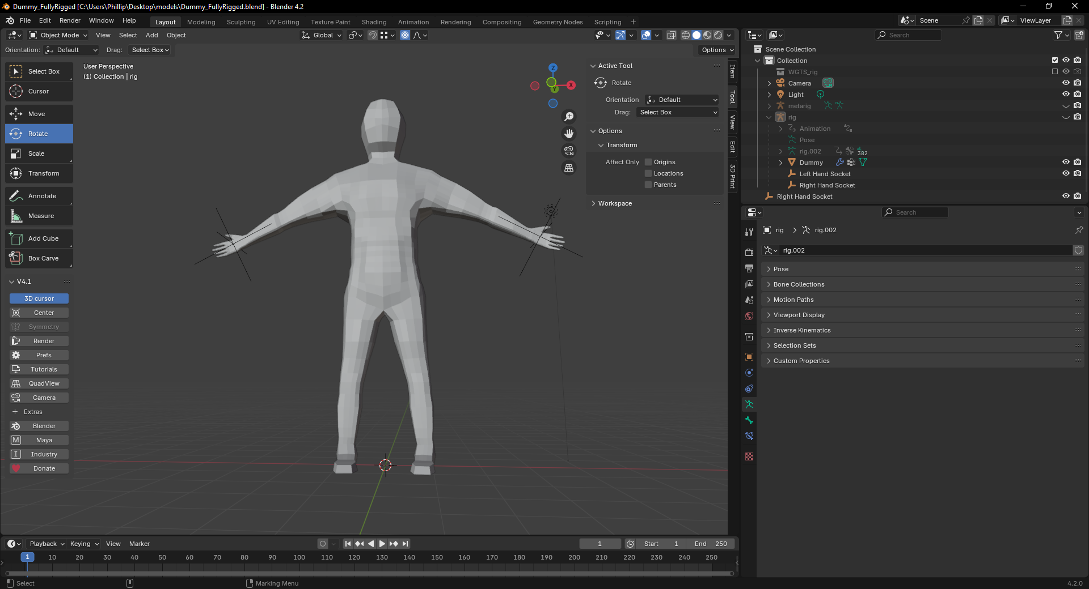
- The tool selection is on the left of the screen instead of the right, which is also collapsible through pressing “T”.
- Directly above this menu is home to the mode select, the long dropdown that says object mode in the image. The options for just about everything will change based on what is selected. You can always go to object and edit mode, no matter what is select, if you get scared, just tab back. This can be changed by clicking the “TAB” key.
- The hierarchy is on the top right of the screen, not along the left of the screen. The hierarchy also works differently than most; anything that gets added is added as a new item in the collection, but more commonly, it will add it as a child of an object in the scene. To un-parent it, you can either drag its name to an empty space or delete the parent. There’s a keybind I just don't know.
- In the top right of the viewport is the properties tab. Going through that, you can find a selected object's location, rotation, and all that fun stuff. There are addons that you can add to it, but you'll find all the basics by default.
- Under the hierarchy is a lot of stuff; for the most part, you guys will likely care about modifiers that live in there. Modifiers are the blue wrench; this will only show up when you have selected the mesh named “Dummy” or any other object in the scene. This menu will change based on what is selected, so if you can't find something, try selecting a different object
- Above the properties tab, you’ll find your display options, which can change from shaded to full render, to some other stuff (it's configurable). For the most part, leave this alone; you will care more about what's directly left of it. Besides the three spheres, there is an X-ray button. This is useful for animation, as you won't keep selecting the mesh because it’s in front of the bones. BEWARE, this function will make it so that clicking and dragging will move anything under the mouse. If that happens, hit undo (CRLT + Z) and turn the setting off
- Moving further left from the X-ray are three more buttons that you can't touch without hurting anything other than your workflow.
- In the center of that bar, we are looking at the snap tool (the magnet)[ignore the rest of the things there, I don’t know what they do]. I don't think you will need this unless you want to make your own props, in which case you will want to use the drop-down menu to interact with it. Keep in mind that if you want to merge two points (vertices, lines, or faces), turning this on and setting it to the appropriate snap point is how you do it.

Important Keybinds
- I used the Maya keybinds extension that I mentioned before, so many of those are the same, but I will go over them here. I am also assuming you have this installed.
  - Disclaimer: I have no idea what the keybinds are for the default Blender. I know you can change the keybinds to an industry-standard mode that makes them similar to Maya.
- Camera movement is the same as Maya, minus Maya's fluidity; you can't combine movements as well. So make sure you hold left alt as you try to move the mouse.
- Clicking an object, then right-clicking while in edit mode, will bring up the tool select that you have in Maya. For the most part, this will be all you need.
- Spacebar will open the camera plane mode, unlike maya you can just move the camera out of these modes, so be careful you don’t do that.
- To extrude, you will press CTRL + Right Mouse button. This extrudes to the cursor, so set up your camera on a flat plane to make positioning easier.
- In many menus, you won't be able to use CTRL + F or Spacebar to open the search function. With this plug-in, I found it easiest to press “SHIFT + Right Click” then click the Spacebar in that menu. Then search like normal.
- If you add props, you will want to parent them to one of two spots, either the mesh or the rig. Which one you choose depends on the prop. If it gets animated, the rig will probably be safer; if it's cosmetic, then the mesh should be able to handle it.
  - ALWAYS SELECT THE OBJECT YOU ARE ADDING FIRST, THEN SELECT THE OBJECT THAT YOU WANT TO PUT IT ONTO.
  - To parent to the rig: you will want to select the bone that the prop will move with the most, then click “CTRL + P”, then choose “bone”.
  - To parent to the mesh: you will select the mesh, then click “CTRL + P”, and choose “With automatic weights.”
    - To cancel this action, just move your mouse out of the pop-up window. ESC might also work.

Basics (model)
- The main model, as referenced in that long post before, is designed with the male figure in mind; however, the model can be (and should be) sculpted as needed to fit any model.

- The goal of this model is to have a base to work off, so keep that in mind, you don't need to keep the model if you want to make your own, but I highly recommend it, it would probably be best to just add your props on top or make your new model on top and parent it to the rig if needed.

Rigging adjustments
- While I hope you won’t need to make these, just in case.
- You will have to recreate the rig if you change the bone placements. The rig was made by referencing the model at the time of creation. Once made, it forgets that there are bones beneath the model.
- To safely do this, in the hierarchy, click the rig object (as a whole), then right-click it, then click delete.
  - You might have to re-bind the sockets if you do this; all you have to do is parent the sockets to the hand portion of the rig when you make it again.
- Then click on the meta-rig object and make your adjustments in edit mode.
- When you are ready to make a new rig, you can find a tab in the bottom right called Data (it's the stick man). In there, you will find a tab called “Rigify” where you will see create (or Generate) rig, click that.
- Lastly, make sure you reparent everything you need, being the sockets and the mesh, to the rig.

Props
- All that needs to be done here is to place the center of your prop in the correct spot, then add a constraint on the object to follow the position and rotation of the socket you want the prop to be on.
  - https://youtu.be/07rSFBpsW9k?si=Rs01BAqlGgYwh48a. This video explains how to manipulate the center point.
- If you don't want to fuck with the center location, you could add a parent empty to the prop that acts as the pivot point. Then put the constraints on the empty.
Holsters/sheaths
- Works the same as hand sockets, but you will have to set keyframes in the animation to swap between the two sockets.
  - It's easiest to do this by making them move as booleans, so they either follow one or the other. This is also scalable if you want 2 or more locations.
    - If you need help with this, I will be using them for my character, so I will be able to help.

Pitfalls
- Mostly, you should be able to work without issue. BUT there are some parts that could cause issues due to my inexperience at modeling organic figures.
  - If there are any triangles (I believe there are only 8), these can cause stretching of the mesh once textured. I highly doubt anyone will see them as they are on the side of the torso and near the shoulder, but still.
- I have not made UVs for the model yet, mainly because I am not sure how we are going about making our character, plus each character will probably be a different shape, so doing it now wouldn’t make sense.
- I have not looked at clothing yet; that will come after I animate the main movements of my character and start making him look like what I envisioned.
- For now, I recommend that if anyone is to start animating with me, just get the keyframes, and then we can go from there.

